FREQUENTLY ASKED QUESTIONS

The following documents are frequently asked questions specific to NET2000 that assist you in resolving problems you may encounter.

MODEM PROBELMS
- Error 680: There is no dial tone.
- Error 630: The computer is not receiving a response from the modem.
- How do I test my modem to see if is working properly?
- Modem dials but won't connect.
- Modem passes diagnostic but fails to dial.
- Why does my modem/connection keeps dropping out?
- I have to dial a few times before connecting, what is the problem?
- How can I configure my modem to dial properly?
- How do I install my modem?
- What is the initialization strings for my modem?
- I have a 56kbps modem, why am I connecting at lower speeds.

DIALUP NETWORKING PROBLEMS
- Error 691: The computer you are dialing is not responding, check the username or password.
- My connection speed is very low, what can I do?
- I dial in, connects but a window pops up prompting for IP address
- I dialled in, connected but I can't browse the net or check my email
- I dial in but get an engage signal, line busy.
- Dialup Networking cannot negotiate a set of network protocols.

EMAIL PROBLEMS
- It keeps asking me for my password
- My email comes down very slowly.
- I cannot send out email.
- How can I use my email anywhere in the world? Use Webmail.
- I cannot access Webmail, it keeps saying 'Page can't be displayed'.
- Dialup Networking cannot negotiate a set of network protocols.

BROWSER PROBLEMS
- Page cannot be displayed.
- How do I remove content advisor?
- I keep getting 'Script Errors'
- I getting 'Error 4.04' or 'Cannot open the Internet site. A connection with the server cannot be established?
- I keep getting DNS error.
- The pages seem to load very slowly. My downloading is slow.
- Internal Server Errors.

MODEMS PROBLEMS - SOLUTIONS
- Error 680: There is no dial tone.
When you get this error, it means your modem is not receiving the signal from the telephone line.
- Make sure the telephone line is plugged in securely at both ends (at the wall and at the back of modem).
- Make sure the telephone line is plugged into the right socket (usually labeled 'LINE').
- Test the telephone line by plugging the line for the modem to a handset and pick up the handset, make sure you can hear the telephone signal.
- Make sure no other software is using the modem (press CTRL-ALT-DEL to check).
- Make sure there's no interrupt request (IRQ) conflicts with the communication ports. To check, go to Control Panel, System and click on Device Manager.
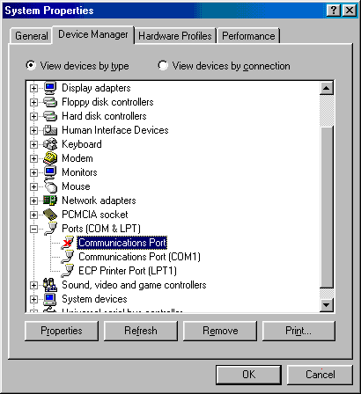
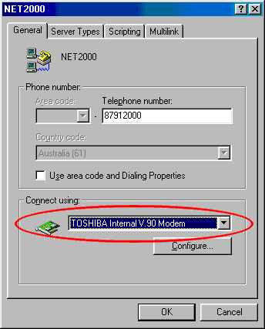
- Make sure the modem is correctly selected under dialup networking. Go to My Computer, Dialup Networking and click on the connection icon with the right mouse button then select Properties.
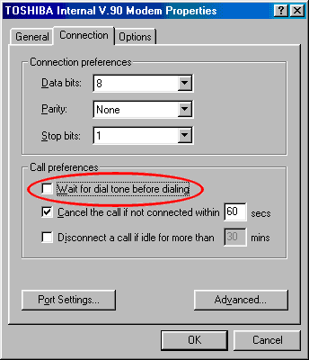
- If you have done the above and you still get no dial tone, try taking off 'Wait for dial tone before dialing' under connection properties. Go to My Computer, Dialup Networking and click on the connection icon with right mouse button and then select Properties. Click on Configure then Connection and untick the box 'Wait for dial tone before dialing'.

- Error 630: The computer is not receiving a response from the modem.
The computer is unable to detect the modem
- Make sure the modem is connected properly.
- Make sure the modem is switched on.
- Check the power adapter for the modem, make sure it is the right one for the modem (i.e. right voltage & current specification).
- Make sure the modem driver is installed properly and the right COM port is selected for the driver.
- Most computers have two communication ports, make sure the modem is plugged in the right COM port. Swap between the two ports if necessary.
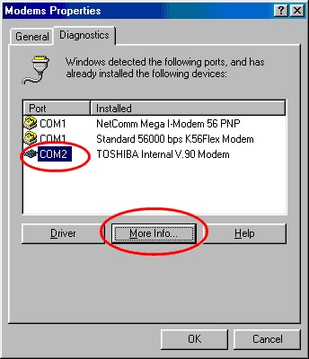
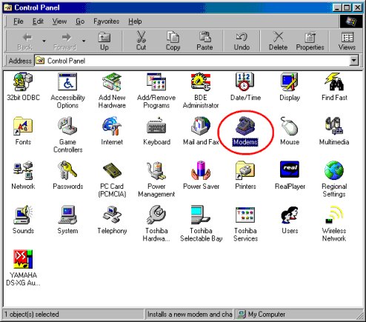
- Perform a diagnostic on the modem: Go to Control Panel, Modem and click on Diagnostic. Highlight the COM port the modem is connected to, then click on More Info and wait for the response. If you have an external modem, look at the modem lights; make sure they flash back & forth. If the modem fails to respond, the modem needs to be repaired or the modem driver may need to be re-installed. If the modem respond successfully, then the modem driver may not be selected properly under dialup networking as shown on the second image from the previous page.

- Why does my modem connection keep dropping out?
This is problem is almost inevitable in an analogue system in which the modem still uses. With an analogue system noise and interference is very susceptible.

